Course Methods Year 12 test one 2022

Student name: ________________ Teacher name: ________________

Task type: Response

Time allowed for this task: _____40______ mins

Number of questions: ____8_______

Materials required: No calculators nor classpads allowed

Standard items: Pens (blue/black preferred), pencils (including coloured), sharpener, correction fluid/tape, eraser, ruler, highlighters

Special items: Drawing instruments, templates, notes on one unfolded sheet of
A4 paper.

Marks available: ___40___ marks

Task weighting: __10__%

Formula sheet provided: Yes

Note: All part questions worth more than 2 marks require working to obtain full marks.

Q1 (3, 4 & 3 = 10 marks)
Differentiate the following:

Solution
Specific behaviours
P correct power
P uses factor of 5
P uses factor of 3
(no need to simplify)

- and simplify

Solution
Specific behaviours
P uses product rule
P uses chain rule for bracket term
P obtains a correct expression
P shows a fully simplified expression

- (do not simplify)

Solution
Specific behaviours
P uses quotient rule
P correct denominator
P correct numerator

Q2 (4 marks)
Determine the equation of the tangent to at

Solution
Specific behaviours
P uses product rule
P determines gradient
P sets up a constant and equation to solve
P states tangent line
Q3 (5 marks)
Determine the coordinates of the stationary points and their nature for . Justify.

Solution
Specific behaviours
P determines first derivative
P equates derivative to zero
P solves for x values of both stationary pts
P uses a derivative test and shows values to determine nature
P determines y values of stationary pts

Q4 (3 marks)
The displacement of a body from an origin O, at time seconds, is metres where

Determine the velocity and the displacement of the body when the acceleration is zero.

Solution
Specific behaviours
P differentiates to determine velocity and acceleration
P equates acceleration to zero and solves for t
P states velocity and displacement for this time

Q5 (4 marks)
Consider the function which is graphed below.
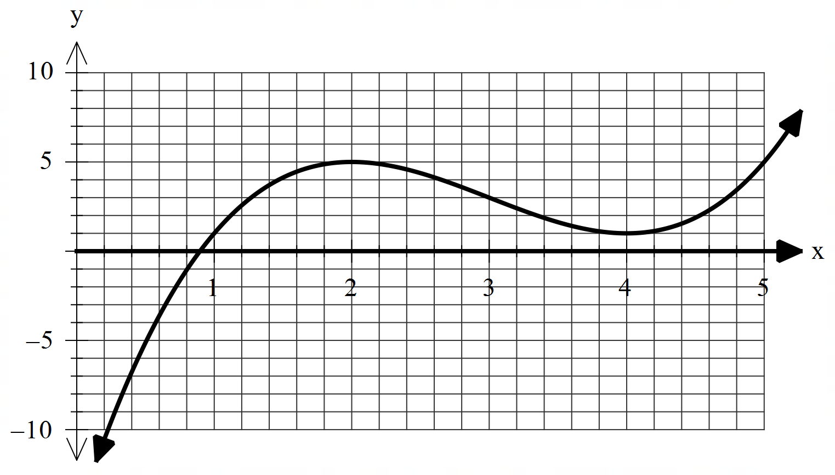

On the axes below, sketch the gradient function indicating on your sketch the location of any stationary points and any inflection points. (labelled)

Solution
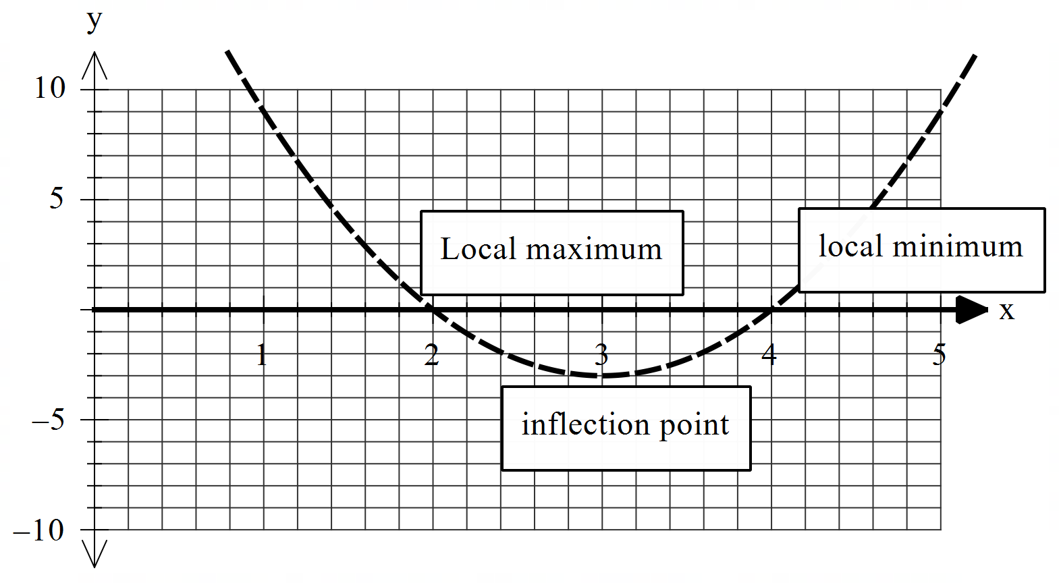

Specific behaviours
P correct shape being concave up with a min turning pt (location may differ)
P labels local minimum (accept min)
P labels inflection pt
P labels local max (accept max)
Note: No follow through if sketch is wrong as original function given & do not accept turning pt)
Q6 (2 & 3 = 5 marks)
Consider the function where .
- Using the increments formula (small change) determine an approximate value for and express this as an approximate percentage change again using the increments formula.

Solution
Specific behaviours
P uses increments formula
P determines approx. g(2.1)

- The volume of a sphere of radius metres is given by . Using the increments formula determine the approximate percentage change in volume for a 3% change in the radius.
Solution
Specific behaviours
P sets up an expression for percentage change in volume
P simplifies expression
Psubs % change for r to give approx. % change in V

Q7 (4 marks)
Let equal the number of hectares that a farmer will use to grow corn one season. The amount of corn to be harvested per hectare is given by kg for . Using calculus determine the number of hectares that should be used to maximise the amount of corn produced.

Solution
Specific behaviours
P determines expression for total amount of corn
P differentiates and equates to zero
P solves for A (no units required)
P shows using a derivative test that this is a local max

Q8 (5 marks)
Let the cost, $, to make items in a factory be given by dollars. Using calculus show that the minimum average cost per item is equal to the marginal cost at this number of items.
Solution
Specific behaviours
P determines exp for average and differentiates
P equates derivative to zero and solves for x
P shows with derivative test that local min
P shows marginal cost formula
Pshows both equal at required x value

